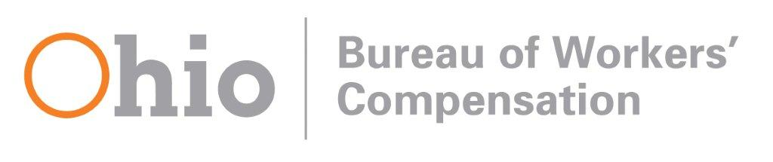

Ohio BWC Social Media Acceptable Use Policy
The Ohio Bureau of Workers’ Compensation (BWC) welcomes your social media comments related to workers’ compensation.

The comments and opinions expressed by members of the public are theirs alone and do not reflect the opinions of BWC or its employees. BWC reserves the right to remove posts, in their entirety, determined not to be in compliance with this policy.
- Posts should be limited to workers’ compensation or relevant topics.
- The use of vulgar, offensive, threatening or harassing language is prohibited.
- Political statements, including comments that endorse or oppose political candidates or ballot issues, are prohibited.
- Promotion or advertisement of services is prohibited.
- Posts containing allegations of fraud are prohibited. To report fraud, please use our online fraud allegation form at bwc.ohio.gov or call our fraud hotline at 1-800-644-6292.
- Individuals who repeatedly violate this policy may be permanently banned from posting to Ohio BWC social media sites.
- Posts to Ohio BWC social media sites are public records.
- Communications made through Ohio BWC social media sites will in no way constitute a legal or official notice to BWC or any official or employee of BWC for any purpose. For example, a post or comment that asks that BWC provide public records will not be considered a public records request. A post that attempts to appeal a BWC order or decision will not be considered a valid or timely appeal. A post or comment related to a proposed agency rule will not be considered by the agency. For assistance on these issues, please call us at 1-800-644-6292.
The Ohio BWC social media acceptable use policy is subject to amendment or modification at any time.
Questions or concerns regarding Ohio BWC social media sites should be directed to the social media team at: bwcsocialmedia@bwc.state.oh.us.

Updated Jan. 10, 2020

