FAQ: Electronic Payments for Attorneys

What payments are eligible for electronic funds transfer (EFT)?
EFT is available for lump sum advancements for attorney fees for awards of permanent total disability, death benefits and scheduled loss benefits. Payments to attorneys and law firms for family support and statutory fees awarded by the court system also qualify for EFT.

Payments for policy refunds, payments with joint payees and payments in care of an injured worker or another party are not eligible for EFT. We will continue to make those payments by check.

Can I file this form online?
No. You must print and complete the EFT application for direct deposit. You then must sign, date and return it to the BWC benefits payable department along with an IRS W-9 form and a voided check containing your banking information and account number.

Where can I find the application?
You can find the form on the BWC website, www.bwc.ohio.gov. Under the Worker section, select Claim Policies. Choose Tools for authorized representatives under Other Important Resources. You’ll find the form in the Services section.

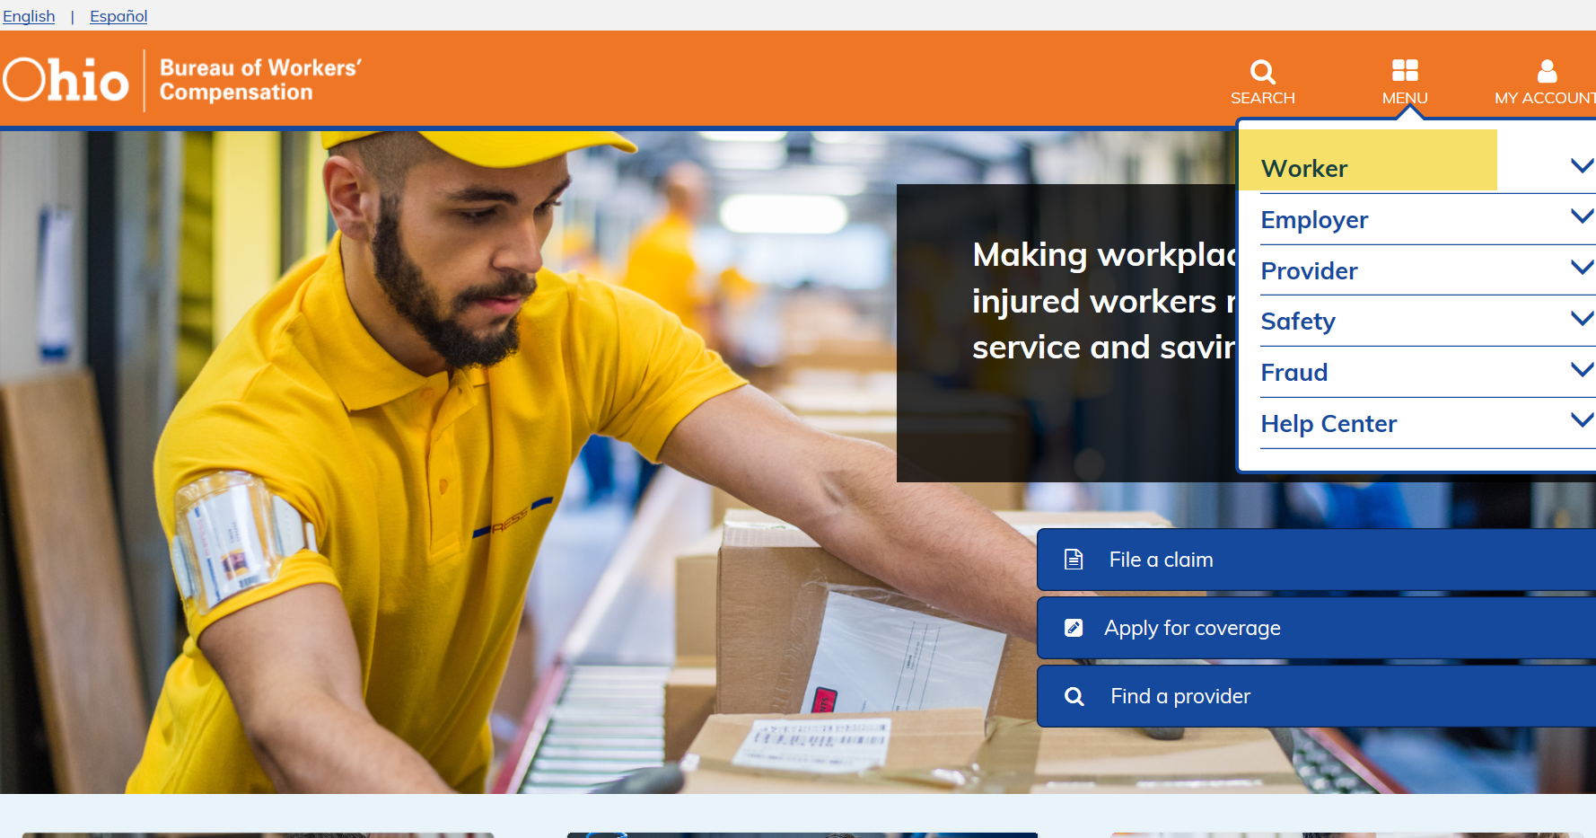

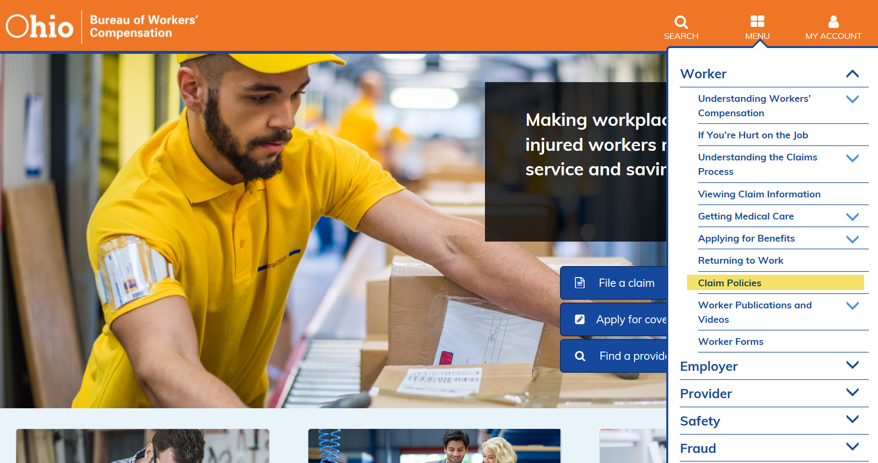

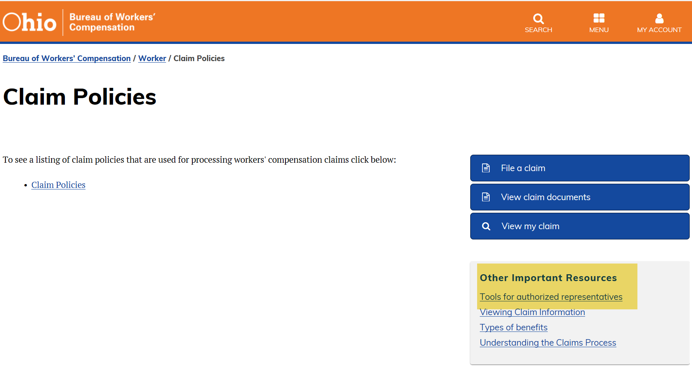

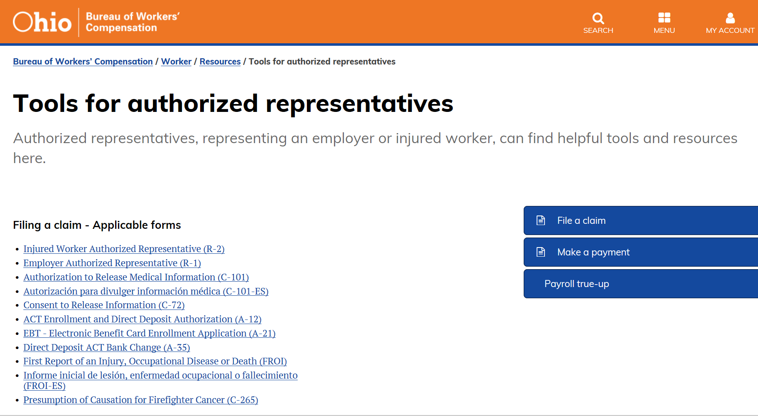

Where do I find the IRS W-9 form?
You can find the IRS W-9 form on the IRS website, www.irs.gov. Select the Forms & Instructions menu, then find the W-9 form in the menu. Print and complete it.
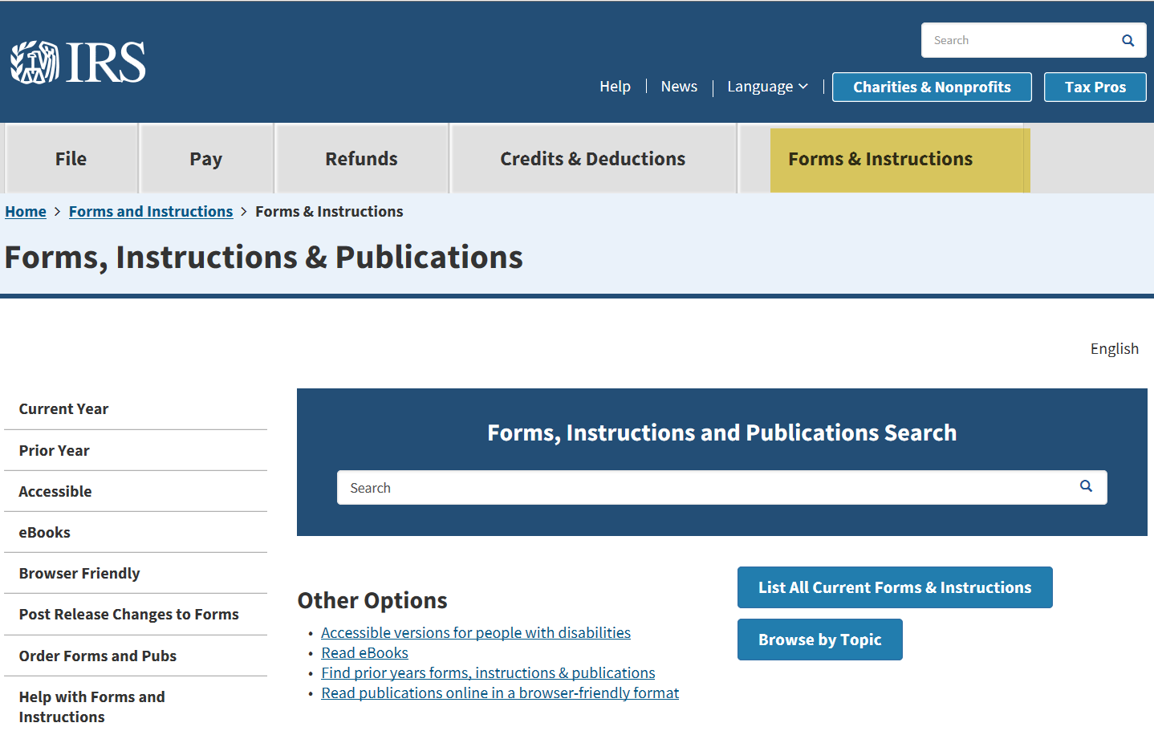

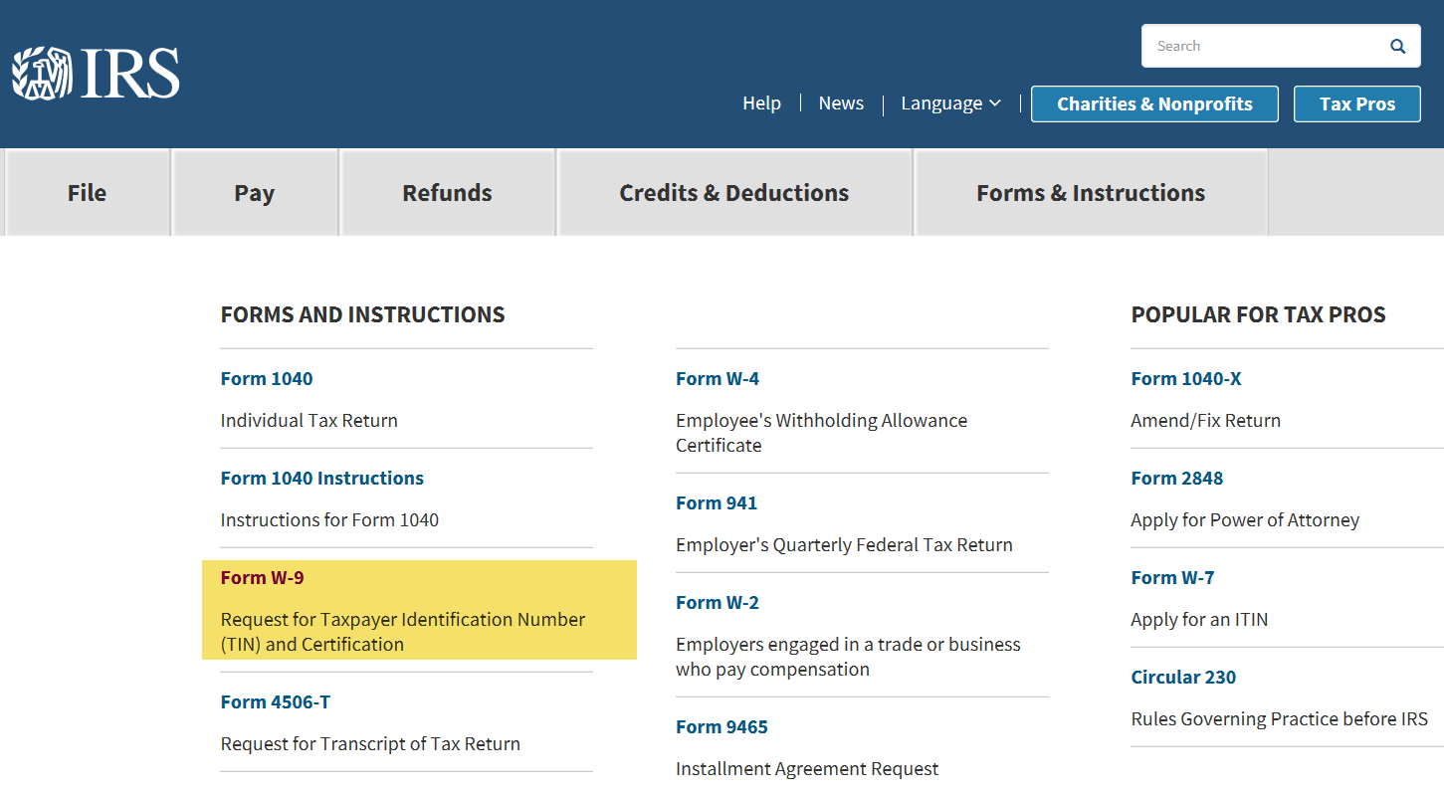

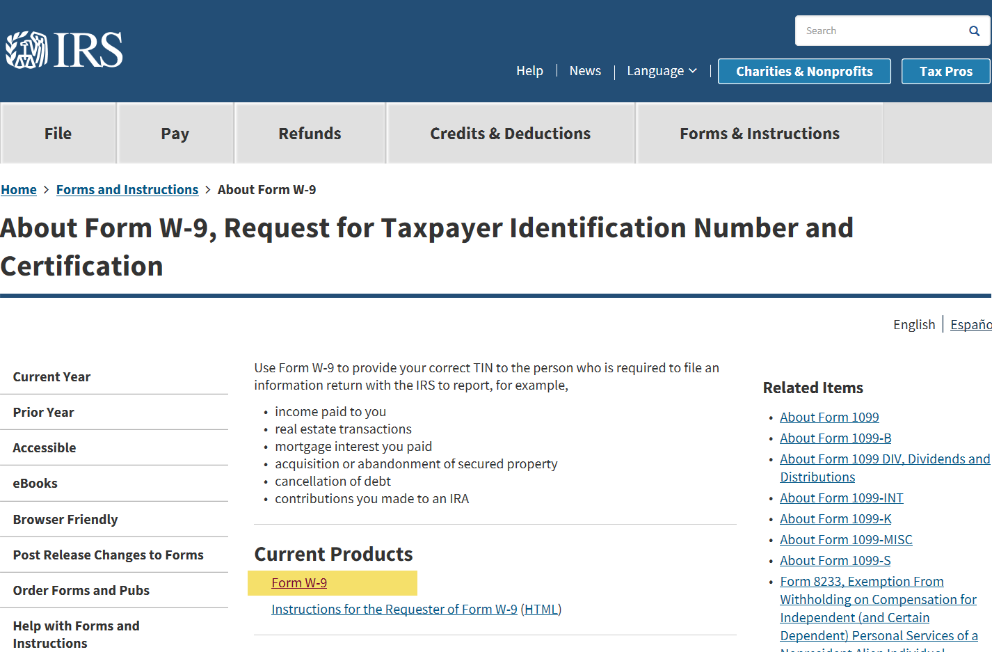

Be sure to complete all highlighted areas as applicate, sign and date.
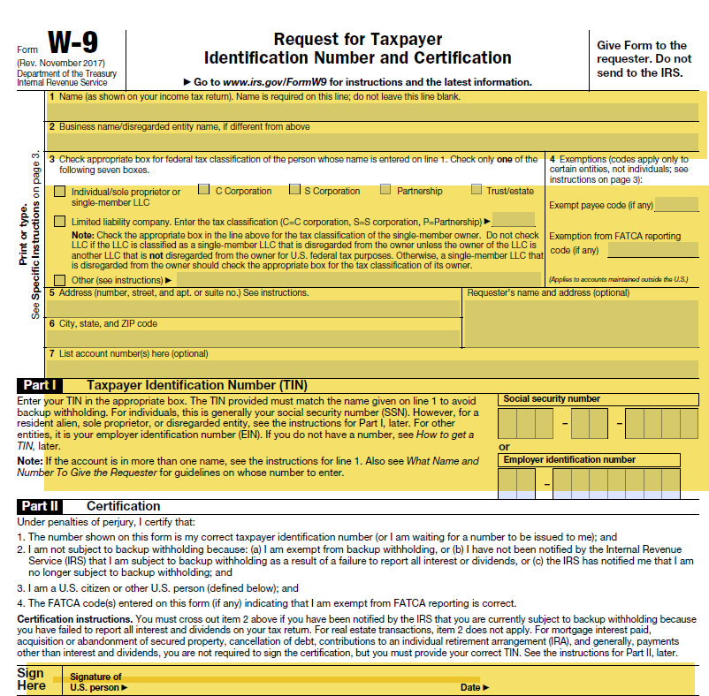

Why do I have to file the IRS W-9 form?
The IRS requires us to keep the W-9 form on file to verify your taxpayer identification number. This number is your employer identification number. We use W-9 information to issue 1099 forms to you for amounts we paid to you during the calendar year.

Do I have to file the IRS W-9 form?
Yes, the IRS requires it. We can’t process your request for electronic payment without the IRS W-9 form.

Will you let me know when I’m signed up for the EFT program?
Yes. We’ll mail a letter to you once we’ve entered your EFT information into our system.

Where do I send the forms?
Send the documents to the BWC benefits payable department by fax at 614-621-1140, email through a secure e-mail to eftgroup@bwc.state.oh.us, or by mail to:
Ohio Bureau of Workers’ Compensation
Attn: Benefits Payable
P.O. Box 15429
Columbus, OH 43215

What if I have questions?
You can call the benefits payable department at 614-728-0741.

